|  |  |  |
| --- | --- | --- |
|  | **BAHRIA UNIVERSITY, (Karachi Campus)**  *Department of Software Engineering*  **Assignment 1 - Spring 2022** |  |



COURSE TITLE: Engineering Management COURSE CODE: **MGT-423**

Class: **BSE-IV (B)** Shift: **Morning**

Course Instructor: **Engr. Talha Bin Saeed** Time Allowed:  **4 Weeks**

Submission Date: **25/05/2022** Max. Marks:05

**Name: Abdul Quddos Enrollment No: 02-131203-033**

**[CLO1: 5 Marks]**

**QUESTION #01**

Select an engineering problem from an organization of your choice and apply the 5-step engineering problem solving approach in detail for the problem to be solved. Also comment on the simplicity of the steps involved in the problem solving approach.

**Answer:**

Five steps of engineering problem and the problem discussed and solved in the below steps:

1. **Define the problem:**

Make a bridge which is flexible and movable when big ships come towards the bridge to pass through the bridge area.

1. **Collect and analyze the data:**

Movable bridges are of several types that can move to accommodate the passage of boats and ships.

Many methodologies are used to make these kinds of bridges. Basically the main idea behind that we use it as a fulcrum and like a seesaw. So we make fulcrum point and for handling the situations like boats arriving, barges and we make it counterweight so can uphold easily but strong. For moving we can fit

1. **Search for solutions:**

There are different methodologies for making this kind of bridge.

1. draw bridge.

2. bascule bridge.

3. folding bridge.

4. curling bridge

**4. Evaluate alternatives:**

* If we make drawbridge , unfortunately draw bridges is not a perfect structure as it does use a lot of resources and time to create. Depending on the material a drawbridge can use more than eighty tons. Drawbridges found outside of port city are usually made from concrete and steel which averages around eighty tons of material which has to be extracted from the earth and processed, which promotes air pollution.
* If we make bascule bridge then it have many great impacts like it would have great benefit if the bascule bridge can’t open completely but the smaller boats and ships can passed under through the bridge. It would not suffer from considerable collision damage.it requires not more time to completely open bridge compared to other types of bridges.
* If we make swing bridge, then it have required minimum load then other types of required bridges, but It have some disadvantages like it requires large number of maintenance because larger number of moving parts.
* If we choose the curling bridge then the problem arise is that the curling bridges have many movable parts more than swing bridges so it requires greater maintenance and if any movable part can affected then the consequences would face all the bridge.

**5. Select Solution and evaluate the impacts:**

So, after all kind of assumptions, dependency, advantages and disadvantages we make the bascule bridge because it permits all kinds of boats small large or even the largest boats and provide a minimum time for opening for boats and no any kind of collision danger in case of 2-leafed bridges and minimum resources to utilize on the bascule bridge. THG concept used for this kind of bridge uses Trunnion-Hub-Girder bridge it easily tackle counterweight.

The formulae used in this way is:

(Delta)D = D X alpha X (Delta)T

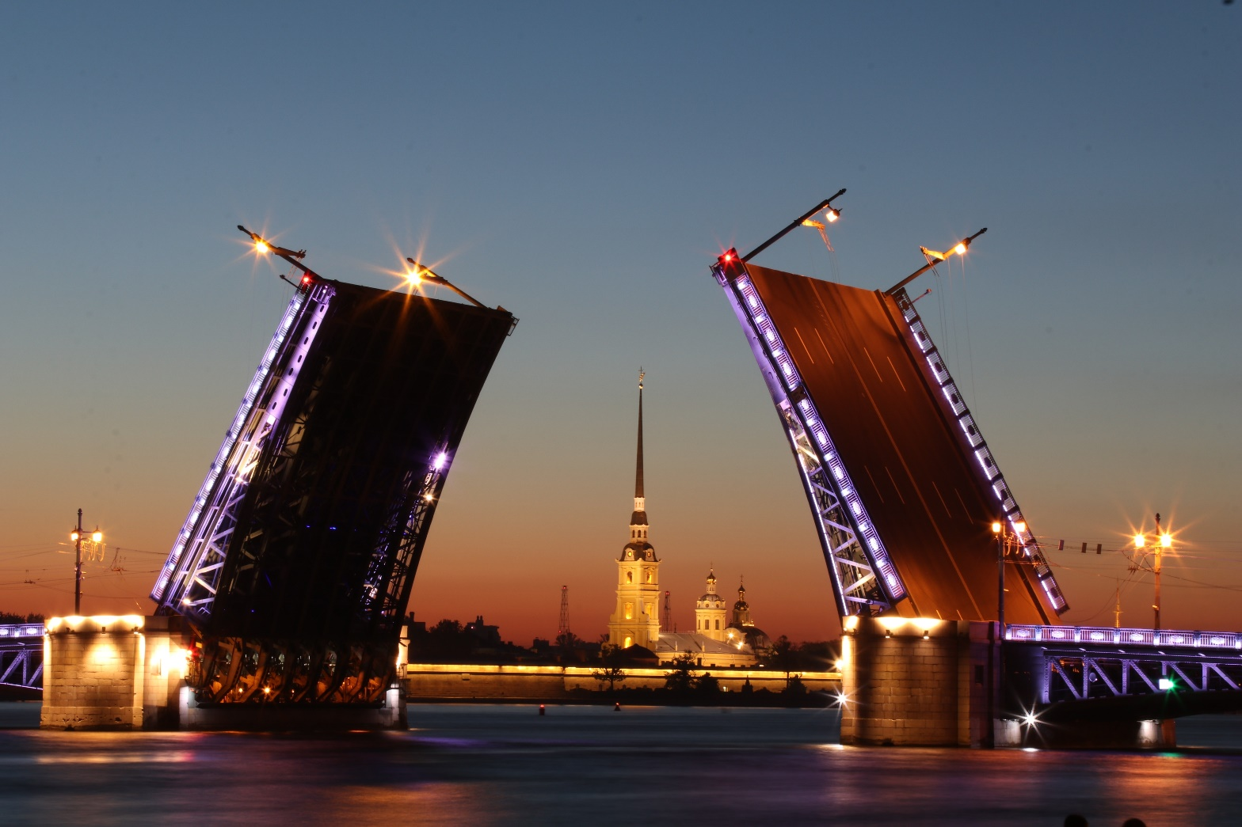

Source : https://www.pexels.com/photo/afterglow-architecture-bridge-building-462218/

**Bascule Bridge**

**References:**

1. **Draw backs and benefits of drawbridges:** https://eduzaurus.com/free-essay-samples/drawbacks-and-benefits-of-the-drawbridge/
2. **12 different design for movable bridges:** https://www.core77.com/posts/53351/12-Different-Designs-for-Movable-Bridges-Animated-For-Your-Pleasure
3. [**www.researchgate.net**](http://www.researchgate.net)

(All referred on 23/5/22)